10-Year Capital Market Forecasts (2026-2035)
Asset Class Returns, Standard Deviations, Correlations and Tail Assumptions
January 2026

Synopsis
Fiducient Advisors updates asset class assumptions at least annually to reflect 10-year estimates for asset class returns, standard deviations, skewness, kurtosis and correlations. This paper details our input assumptions for the investment period from January 2026 to December 2035.
Source: Fiducient Advisors Capital Market Assumptions. Market and economic data including, but not limited to, valuations, fixed income yields and inflation, are used to derive forecasts. Outputs and opinions are as of the date referenced and are subject to change. Information is intended for general information purposes only and does not represent any specific investment recommendation. Please consult with your advisor, attorney and accountant, as appropriate, regarding specific advice. There is no guarantee that any of these expectations will become actual results. Past performance does not indicate future performance and there is a possibility of a loss. For additional information on forecast methodologies, please speak with your advisor. Please see Index Proxy Summary information at the end of this paper for summary of indices used to represent each asset class.

1) Dynamic bonds are a blend of 33% Cash, 33% Corp HY, and 34% Global Bonds. 2) Tax Equivalent yield based on highest marginal Federal tax rate (37%). 3) Broad Real Assets is 20% REITS, 20% Global Infrastructure, 20% Commodities, 20% US Bonds, 15% Corp High Yield, 5% TIPS. 4) Morningstar Direct. Based on MSCI ACWI, as of October 31, 2025.
10-Year Return Forecasts by Asset Class
INFLATION (CPI): Inflation is used as a building block of total return for several asset classes. Our forecast of inflation is the difference between the 10-year nominal U.S. Treasury yield and the 10-year TIPS real yield. As of October 31, 2025, this difference was 2.30% (i.e., 4.11% - 1.81%). We believe this implied breakeven inflation rate (2.30%) is a rational median case assumption regarding CPI inflation for all items in the Consumer Price Index over the next 10 years. The following are the implied breakeven and our forward CPI expectations based on current breakeven inflation relationships.

Historical 10-Year U.S. Nominal and Real Rates (As of October 31, 2025)
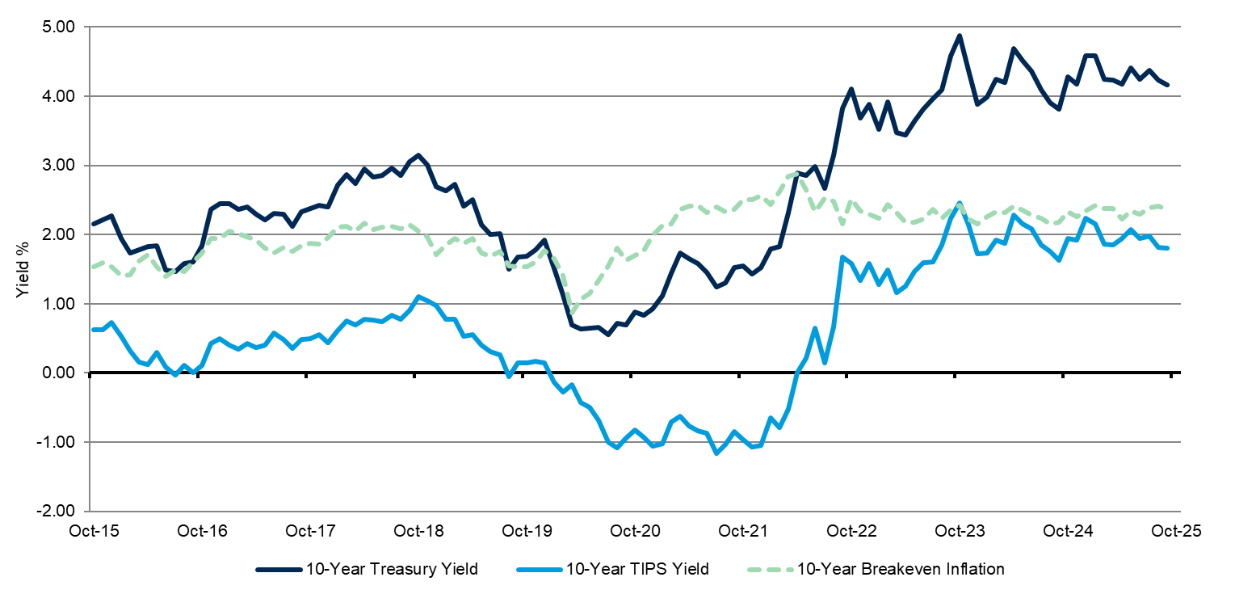
Source: FactSet. As of October 31, 2025
Source: FactSet. As of October 31, 2025

The curve is pricing in steady inflation over the next 10 years with a modest increase and then decrease thereafter.
10-Year Forecast of Annual CPI: 2.3%

Use of Indices and Benchmark Return Indices cannot be invested in directly. Index performance is reported gross of fees and expenses and assumes the reinvest dividends and capital gains. Past performance does not indicate future performance and there is a possibility of a loss. See disclosure page for indices representing each asset class.

TIPS: As of October 31, 2025, the Bloomberg U.S. TIPS Index had 48 issues (all U.S. Sovereign) with an average real yield of 1.74% and an average maturity of 7.32 years.
Source: FactSet. As of October 31, 2025

Combining the real yield of the Bloomberg Barclays Capital U.S. TIPS Index (1.74%) with our forecasted inflation (2.30%) leads to an expected return of 4.04%.
10-Year Forecast of Annualized Geometric Return: 4.0%

CASH: We utilize a term premium methodology that we believe aligns our forecast with a 10-year outlook. Our cash forecast takes the current 10-year Treasury yield and discounts the yield by the 40-year historical average term premium between the 10-year Treasury Bond yield and the 3-month Treasury Bill yield (10-year yield less 3-month yield). Additionally, we have put a floor on this assumption at 0.0%. As of October 31, 2025, the 10-year yield was 4.1% and the historical average term premium was 1.5%. Our expected geometric return forecast is 2.6%.

Cash Term Premium Method: (YLD) - (TERM)
10-Year Forecast (2026 - 2035): 4.1% - 1.5% = 2.6%
- YLD = Yield of 10-year U.S. Treasury Bond
- TERM = 40-year historical average spread between 10-year Treasury Bond yield and 3-month Treasury Bill yield.
10-Year Forecast of Annualized Geometric Return: 2.6%

SHORT TERM BONDS: The historical duration of the asset class has been steady at approximately two years, which is calculated using blended return assumptions for cash and U.S. investment-grade fixed income. The blended return comes two-thirds from cash and one third from U.S. Investment Grade Fixed Income. Our expected geometric return forecast is 3.25%.
10-Year Forecast of Annualized Geometric Return: 3.3%

Use of Indices and Benchmark Return Indices cannot be invested in directly. Index performance is reported gross of fees and expenses and assumes the reinvest dividends and capital gains. Past performance does not indicate future performance and there is a possibility of a loss. See disclosure page for indices representing each asset class.
U.S. TAX-EXEMPT (MUNICIPAL) FIXED INCOME: As of October 31, 2025, the Bloomberg Municipal Bond 5-Year Index had 6,633 issues with an average maturity of 4.96 years and an average duration of 3.64 years. The index is investment-grade rated.
Source: FactSet. As of October 31, 2025

Our tax-adjusted return forecast for the Bloomberg Municipal Bond 5-Year Index is found by dividing the current yield to worst by one minus the highest marginal federal tax rate [(2.87% / (1 - 0.37)] = 4.56%.
10-Year Forecast of Annualized Geometric Return: 4.6%

U.S. TAX-EXEMPT (MUNICIPAL) HIGH YIELD FIXED INCOME: As of October 31, 2025, the Bloomberg U.S. Municipal Bond High Yield Index had 5,703 issues with an average maturity of 19.54 years and an average duration of 7.47 years. The index is below investment-grade rated.
Source: FactSet. As of October 31, 2025
Our tax-adjusted return forecast for the Bloomberg Barclays Capital U.S. Municipal High Yield Index is found by dividing the current yield to worst by one minus the highest marginal federal tax rate [(5.63% / (1 - 0.37)] = 8.94%.
10-Year Forecast of Annualized Geometric Return: 8.9%
U.S. INVESTMENT GRADE FIXED INCOME: As of October 31, 2025, the Bloomberg U.S. Aggregate Bond Index had 13,899 issues with an average maturity of 8.24 years and an average duration of 6.02 years. The index is investment-grade rated. The return forecast for the Bloomberg U.S. Aggregate Bond Index is its current yield to worst of 4.33%.
Source: FactSet. As of October 31, 2025

10-Year Forecast of Annualized Geometric Return: 4.3%

DYNAMIC BONDS: The asset class is calculated using blended return assumptions for cash (1/3), corporate high yield (1/3) and global bonds (1/3). The (unbiased) expected geometric return forecast is 4.62%.
10-Year Forecast of Annualized Geometric Return: 4.6%

LONG-TERM BONDS: As of October 31, 2025, the Bloomberg U.S. Long Gov/Credit Index had 3,552 issues with an average maturity of 22.10 years and an average duration of 13.68 years. The index is investment-grade rated. The return forecast for the Bloomberg U.S. Long Gov/Credit Index is its current yield to worst of 5.06%.
10-Year Forecast of Annualized Geometric Return: 5.1%

HIGH YIELD BONDS: As of October 31, 2025, the Bloomberg U.S. Corporate High Yield Index had 1,975 issues representing $1.5 trillion in market value. The yield to worst was 6.78% with an average maturity of 4.77 years and an average duration of 2.85 years. The following charts reflect current high yield bond market metrics and historical spread data.
Source: FactSet. As of October 31, 2025

Use of Indices and Benchmark Return Indices cannot be invested in directly. Index performance is reported gross of fees and expenses and assumes the reinvest dividends and capital gains. Past performance does not indicate future performance and there is a possibility of a loss. See disclosure page for indices representing each asset class.

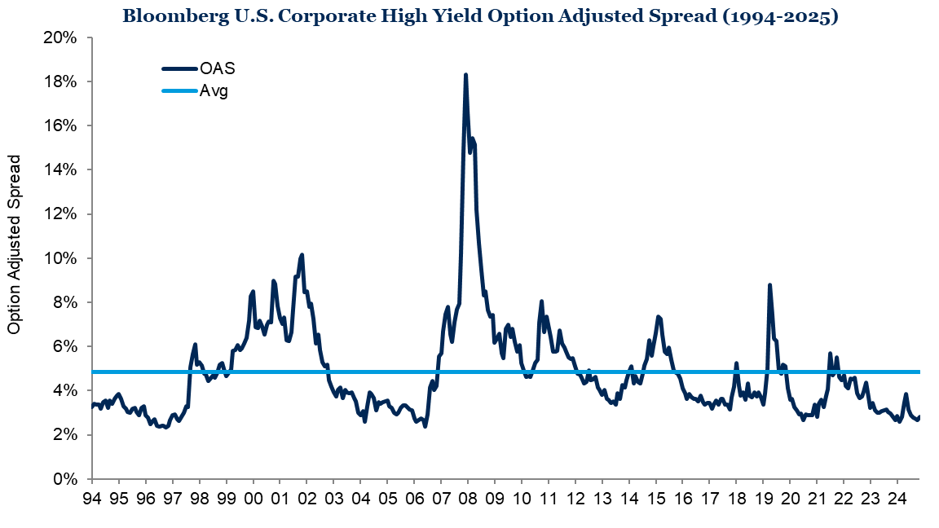
Source: FactSet. From December 31, 1994 to October 31, 2025.
• As of October 31, 2025, the Bloomberg U.S. High Yield Corporate Bond spread over U.S. Treasuries was 2.81%, which is 2.05% below the long-term historical average of 4.86% since December 1994.
• This represents a spread tightening of 1 basis point on a year-over-year basis (from October 2024), which comes from a lower yield on the index (-55 bps), and a decline in Treasury yields (-17 bps for the U.S.
10-Year Treasury).
• From August 1983 to October 2025, the Bloomberg U.S. Corporate High Yield Index returned an annualized 8.33% versus 6.22% for the Bloomberg U.S. Aggregate Bond Index. This represents a historical risk premium of 2.11% for high yield bonds (over investment-grade intermediate bonds).
• Bank of America’s current forecast for U.S. high yield default rate is 2.1% through October 2025, which remains low by historical standards and modestly lower compared to last year.

Use of Indices and Benchmark Return Indices cannot be invested in directly. Index performance is reported gross of fees and expenses and assumes the reinvest dividends and capital gains. Past performance does not indicate future performance and there is a possibility of a loss. See disclosure page for indices representing each asset class.
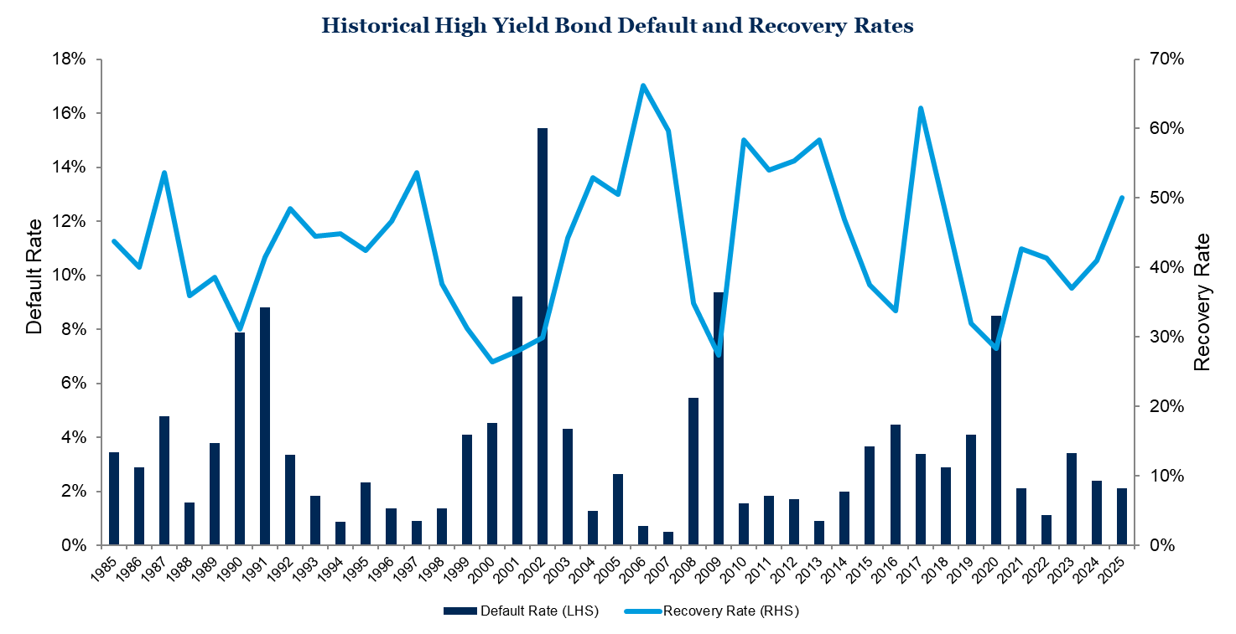
Source: Credit Suisse through 2013, Moody’s from 2014-2021 and Bank of America 2022-2025, including 2025 estimate as of October 31, 2025
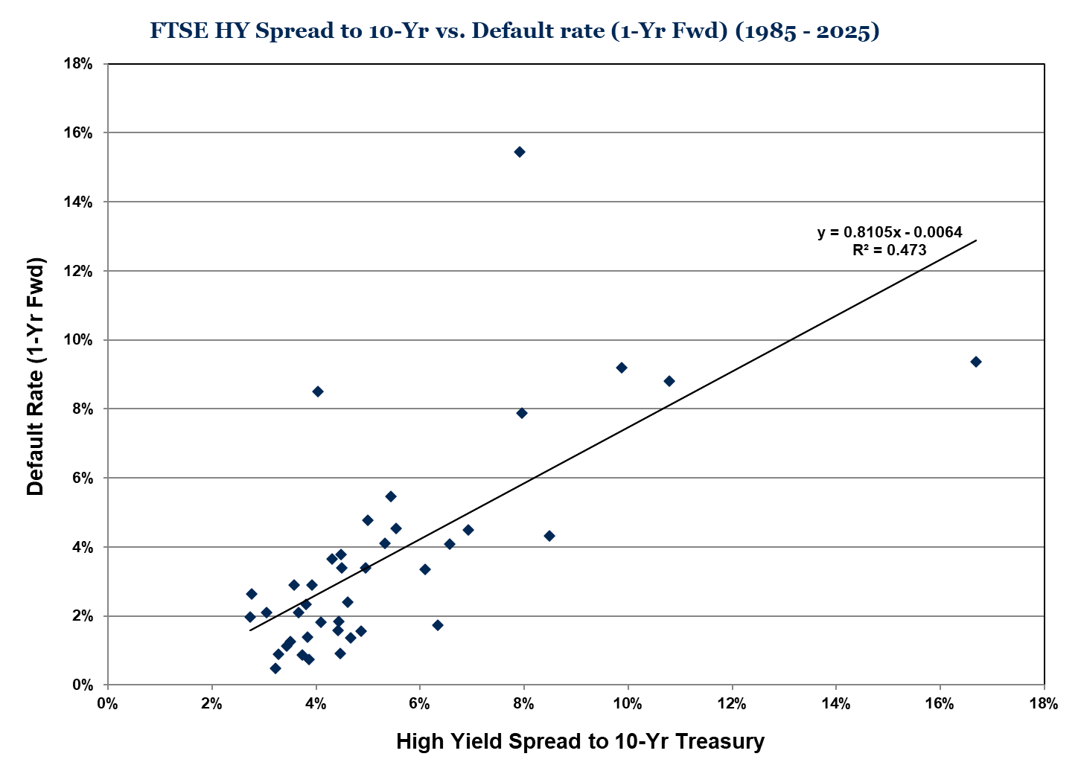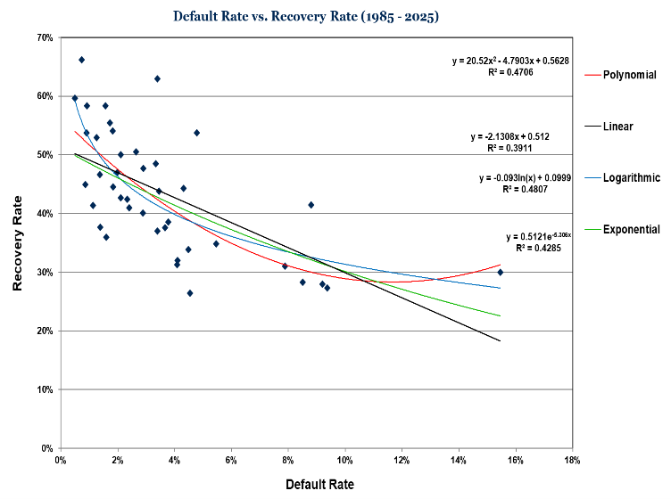
Source: Credit Suisse, Moody’s, FTSE, Bloomberg, Bank of America, Fiducient Advisors Analysis. As of October 31, 2025

• The geometric return forecast is derived from the High Yield Default-Loss Method, where expected return is a function of current credit spreads, our internal expected default rates and expected recovery rates.
• Each year end’s high yield credit spread is used to estimate the following year’s default rate (left pane) from 1985 to 2025 and each year’s actual default rate is used to predict an implied recovery rate using four different mathematical relationships (right pane).

Use of Indices and Benchmark Return Indices cannot be invested in directly. Index performance is reported gross of fees and expenses and assumes the reinvest dividends and capital gains. Past performance does not indicate future performance and there is a possibility of a loss. See disclosure page for indices representing each asset class.
High Yield Default-Loss Method applied as of October 31, 2025
Source: Credit Suisse, Moody’s, FTSE, Bloomberg, Bank of America, Fiducient Advisors Analysis. As of October 31, 2025.

• Based on the High Yield Default-Loss Method, the market is pricing in a 12-month forward looking 1.5% annual expected default rate as of October 31, 2025. This implies an expected recovery rate of around 48%, and subsequent annual loss rate of approximately -0.8%. This represents an estimate based on recent default and recovery rates. We believe the midpoint of the range of all methods reflects a sensible view of default losses over a full market cycle.
10-Year Forecast of Annualized Geometric Return: 6.0%

FOREIGN DEVELOPED FIXED INCOME: As of October 31, 2025, the FTSE World Government Bond ex-U.S. Index had a weighted average yield to maturity of 2.99% with an average maturity of 10.8 years and a 7.36 year average duration. Expected return is calculated by isolating the sovereign index yield and currency and/or credit components of the foreign developed bond market. The sovereign index yield component is calculated by taking the weighted average local bond market yield. Interest rate parity is then used to calculate the expected currency impact embedded in the foreign developed bond markets (in U.S. dollar terms). The difference in like-maturity rates across borders explains the currency Spot-Futures exchange rate relationship. If not, one could borrow in one currency, lend in the other and lock in an arbitrage profit.

Fixed Income Returns Decomposition Method: (YLD) +/- (IRP) +/- (CRE/CUR)
10-Year Forecast (2026 - 2035): (2.99%) + (0.96%) + (-0.11%) = 3.84%
• YLD = Index Yield
• IRP = Interest Rate Parity Currency Adjustment
• CRE/CUR = Sovereign Credit/Currency Adjustment
Foreign Developed Bond Market Data as of October 31, 2025
Source: FactSet, FTSE, Fiducient Advisors Calculations. As of October 31, 2025

The sovereign credit and/or currency premium/(discount) adjustment is applied to individual countries based on their debt-to-GDP ratios and reflects our opinion of how interest parity relationships do not fully reflect the potential for currency debasement (a form of implicit default) or actual potential principal losses due to explicit default.
10-Year Forecast of Annualized Geometric Return: 3.8%

EMERGING MARKETS (LOCAL CURRENCY) FIXED INCOME: As of October 31, 2025, the JPMorgan GBI-EM Global Diversified Index had an average yield to maturity of 6.5% with an average maturity of 7.7 years and a 5.33-year average duration. Expected return is calculated by isolating the sovereign index yield, currency and/or credit components of the emerging markets bond market. The sovereign index yield component is calculated by taking the weighted average local bond market yield. Interest rate parity is then used to calculate the expected currency impact embedded in the emerging markets bond markets (in U.S. dollar terms). The difference in like-maturity rates across borders explains the currency Spot-Futures exchange rate relationship. If not, one could borrow in one currency, lend in the other and lock in an arbitrage profit. In order to isolate each country’s implied credit spread, credit default swaps for each country are used to quantify credit risk above and beyond that of U.S. denominated bonds. This amount is then backed out of each country’s yield in order to be removed from the interest rate parity calculation since implied credit risk is captured in the local bond yield and therefore should not be accounted for in the interest rate parity calculation as well.

JPMorgan GBI-EM Emerging Markets Bond Data as of October 31, 2025
Source: FactSet, JPMorgan. As of October 31, 2025.
Fixed Income Returns Decomposition Method: (YLD) +/- (IRP) +/- (CRE/CUR)
10-Year Forecast (2025 - 2034): (6.49%) + (-2.18%) + (0.23%) = 4.54%
• YLD = Index Yield
• IRP = Interest Rate Parity Currency Adjustment
• CRE/CUR = Sovereign Credit/Currency Adjustment
The sovereign credit and/or currency premium / (discount) adjustment is applied to individual countries based on their debt-to-GDP ratios and reflects our bias for how interest parity relationships do not fully reflect the potential for currency debasement (a form of implicit default) or actual potential principal losses due to explicit default.
10-Year Forecast of Annualized Geometric Return: 4.5%

GLOBAL FIXED INCOME: The asset class is calculated using blended return assumptions for U.S. investment-grade fixed income (40%), foreign investment grade developed sovereign bonds (40%) and emerging market debt (20%). Our expected geometric return forecast is 4.51%.
10-Year Forecast of Annualized Geometric Return: 4.5%

U.S. LARGE CAP EQUITIES: The expected geometric return forecast for U.S. Large Cap Equities (S&P 500) is derived by applying the Cyclically-Adjusted Earnings Yield Method where return is a function of the historical
10-year average real earnings, current price and our 10-year inflation assumption (CPI).

Cyclically-Adjusted Earnings Yield Method: {[1 + (EARNINGS/PRICE)] * (1 + CPI)} - 1
10-Year Forecast (2026 - 2035): {[1 + (188.16 / 6,840.20)] * (1 + 2.30%)} - 1
10-Year Forecast (2026 - 2035): {(1 + 2.75%) * (1 + 2.30%)} - 1 = 5.11%

• EARNINGS = Historical 10-year average real earnings of the S&P 500 Index as of October 31, 2025
• PRICE = Current S&P 500 Index real price as of October 31, 2025
• CPI = Our Inflation Forecast

10-Year Forecast of Annualized Geometric Return: 5.1%

Use of Indices and Benchmark Return Indices cannot be invested in directly. Index performance is reported gross of fees and expenses and assumes the reinvest dividends and capital gains. Past performance does not indicate future performance and there is a possibility of a loss. See disclosure page for indices representing each asset class.

U.S. MID CAP EQUITIES: Using historical correlations and volatility for Large, Mid and Small Cap U.S. Equities (from 1979-2025) and U.S. market cap weights, the Black-Litterman arithmetic return forecast for Mid Cap is 6.8% (vs. 6.5% for Large Cap). Adjusting for forecasted volatility (18.0% Annual Standard Deviation), our expected geometric return is 5.18%.
10-Year Forecast of Annualized Geometric Return: 5.2%

U.S. SMALL CAP EQUITIES: Using historical correlations and volatility for Large, Mid and Small Cap U.S. Equities (from 1979-2025) and U.S. market cap weights, the (unbiased) Black-Litterman arithmetic return forecast for Small Cap is 7.1% (vs. 6.5% for Large Cap). Adjusting for forecasted volatility (20.9% Annual Standard Deviation), our expected geometric return is 4.93%.
10-Year Forecast of Annualized Geometric Return: 4.9%

Black-Litterman (U.S. Mid and Small Cap Equities),
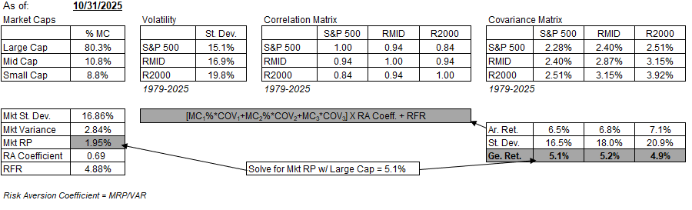
Source: Morningstar. As of October 31, 2025
See the appendix for additional information about the Black-Litterman method.

U.S. ALL CAP EQUITIES: Using relative market capitalization weights, historical correlation, volatility and our forecasted expected returns for Large, Mid and Small Cap U.S. Equities, the expected geometric return forecast for All Cap is 5.17%.
10-Year Forecast of Annualized Geometric Return: 5.2%

FOREIGN DEVELOPED EQUITIES: The expected geometric return forecast for Foreign Developed Equities (MSCI EAFE) is derived by applying the Cyclically-Adjusted Earnings Yield Method where return is a function of the 10-year average real earnings, current price and our 10-year inflation assumption (CPI).

Cyclically-Adjusted Earnings Yield Method: {[1 + (EARNINGS/PRICE)] * (1 + CPI)} - 1
10-Year Forecast (2026 - 2035): {[1 + (147.57 / 2,797.54)] * (1 + 2.30%)} - 1
10-Year Forecast (2026 - 2035): {(1 + 5.28%) * (1 + 2.30%)} - 1 = 7.70%
10-Year Forecast (2026 - 2035): 7.70%

• EARNINGS = 10-Year average real earnings of the MSCI EAFE Index as of October 31, 2025
• PRICE = Current MSCI EAFE Index real price as of October 31, 2025
• CPI = Inflation Forecast

10-Year Forecast of Annualized Geometric Return: 7.7%

EMERGING MARKET EQUITIES: The expected geometric return forecast for Emerging Markets Equities (unhedged MSCI Emerging Markets) is derived by applying the Cyclically-Adjusted Earnings Yield Method where return is a function of the 10-year average real earnings, current price and our 10-year inflation assumption (CPI).

Cyclically-Adjusted Earnings Yield Method: {[1 + (EARNINGS/PRICE)] * (1 + CPI)} - 1
10-Year Forecast (2026 - 2035): {[1 + (85.39 / 1,401.55)] * (1 + 2.30%)} - 1
10-Year Forecast (2026 - 2035): {(1 + 6.09%) * (1 + 2.30%)} - 1 = 8.53%
10-Year Forecast (2026 - 2035): 8.53%
Use of Indices and Benchmark Return Indices cannot be invested in directly. Index performance is reported gross of fees and expenses and assumes the reinvest dividends and capital gains. Past performance does not indicate future performance and there is a possibility of a loss. See disclosure page for indices representing each asset class.
• EARNINGS = 10-year average real earnings of the MSCI Emerging Markets Index as of October 31, 2025
• PRICE = Current MSCI Emerging Markets Index real price as of October 31, 2025
• CPI = Inflation Forecast

10-Year Forecast of Annualized Geometric Return: 8.5%

GLOBAL EX-U.S. EQUITIES: Using relative market capitalization weights (excluding the U.S.), historical correlation, volatility and forecasted expected returns for Foreign Developed and Emerging Markets Equity, our expected geometric return forecast for Global ex-U.S. is 8.27%.
10-Year Forecast of Annualized Geometric Return: 8.3%

GLOBAL EQUITIES: Using relative market capitalization weights, correlation, volatility and forecasted expected returns for U.S. All Cap, Foreign Developed and Emerging Markets Equity, our expected geometric return forecast for Global is 6.46%.
10-Year Forecast of Annualized Geometric Return: 6.5%

PUBLIC REAL ESTATE (REITs): From 1972-2025, the FTSE NAREIT All Equity REITs Total Return Index had a total annualized return of 10.84%. The price component of return was 3.83% with 0.82% (annualized) coming from yield compression (as the dividend yield fell from 6.13% in 1972 to 4.00% in 2025). CPI averaged 3.94% annually, so real price return (excluding yield compression) was -0.93% annually. At 7.01% annually, the dividend was the largest component of return. The following returns decomposition method is used to forecast returns where total return is a function of dividend yields, real price return, yield compression and inflation (CPI).

Modified Returns Decomposition Method: [(DY) + (RPR) + (YLD C) + (CPI)]
Historical FTSE NAREIT All Equity REITs Total Return Index (1972-2025): [(7.01%) + (-0.83%) + (0.82%) + (3.83%)] = 10.84%
10-Year Forecast (2026-2035): [(4.00%) + (0.00%) + (0.00%) + (2.30%)] = 6.30%
• DY = Dividend Yield
• RPR = Real price return excluding yield compression
• YLD C = Return resulting from yield compression
• CPI = Inflation Forecast
10-Year Forecast of Annualized Geometric Return: 6.3%

PRIVATE REAL ESTATE: The asset class return assumption is calculated using the public real estate return assumption plus an alpha assumption of +100 bps as compensation for less liquidity compared to public real estate.
10-Year Forecast of Annualized Geometric Return: 7.3%

BROAD REAL ASSETS: The asset class is calculated using blended return assumptions for REITs (20%), Global Infrastructure (20%), Commodities (20%), Investment-Grade Fixed Income (20%), Corporate High Yield (15%) and TIPS (5%). Our expected geometric return forecast is 6.35%.
10-Year Forecast of Annualized Geometric Return: 6.3%

GLOBAL INFRASTRUCTURE: The current weighted yield on the Dow Jones Brookfield Global Infrastructure Index is 4.12% as of October 31, 2025. Adding the yield to our inflation assumption results in a 6.42% return expectation.
10-Year Forecast of Annualized Geometric Return: 6.4%

COMMODITIES: The expected return for a Commodity Futures index aggregates the expected spot price appreciation of the underlying commodities (expected to match inflation/CPI over a full market cycle), the expected excess return generated from the roll return in a forward contract, and the return from holding T-Bills (or TIPS) as collateral for the futures contracts. As of October 31, 2025, the historical components of return for the S&P Goldman Sachs Commodity (GSCI) and Bloomberg Commodity Indices were as follows:

Commodity Futures Returns Decomposition Method: [(SPOT) +/- (ROLL ) +/- (COLLATERAL)]
Historical S&P GSCI Total Return Index (1971-2025): [(3.09% ) + (-1.24%) + (4.66%)] = 6.51%
Historical Bloomberg Commodity Total Return Index (1991-2025): [(5.41%) + (-4.89%) + (2.66%)] = 3.18%
10-Year Forecast (2026-2035): [(2.30%) + (0.00%) + (4.00% )] = 6.30%

• SPOT = Spot price return, assumed to keep pace with inflation as measured by CPI forecast
• ROLL = Roll return, assumed to be earned from holding a futures contract to (near) maturity
• COLLATERAL = Collateral return, earned by the return of the asset used to collateralize futures/swaps (i.e., T-Bills, TIPS, etc.). Collateral return is assumed to be the midpoint yield between risk free rates (currently 3.89%) and the 10-year Treasury (4.11%).
10-Year Forecast of Annualized Geometric Return: 6.3%

MARKETABLE ALTERNATIVES: The return forecast for Marketable Alternatives is differentiated in that it, along with private equity, are the only investment categories with net positive manager alpha assumptions. That is, the return forecast is not meant to represent a return expectation for the aggregate market, but rather a skillful portfolio of Marketable Alternatives strategies. For purposes of measuring historical risk exposures and correlations to other asset classes, the HFRI Fund of Funds Index, an equal-weighted composite, is used as the proxy. The return, risk, correlation, skewness and kurtosis assumptions are expected to differ on a strategy-by-strategy basis.

Our current 10-year standard deviation (or volatility) forecast for a diversified multi-strategy portfolio of Marketable Alternatives is 8.5%, the same volatility expected of hypothetical portfolio consisting of 63% investment grade U.S. fixed income and 37% global equity mix based on our 10-year forecasts. This fixed/equity mix has a 5.5% 10-year geometric expected return forecast. Our expectation is for a skillful and diversified portfolio of marketable alternative strategies to add 1.5% of excess return (i.e., 5.5% + 1.5% = 7.0%) net of manager fees at approximately the same volatility level. For Liquid Alternatives, the same process is employed but a zero percent excess return is used to arrive at a 5.5% return assumption.

10-Year Forecast of Annualized Geometric Return: 7.0% for Marketable Alternatives & 5.5% for Liquid Alternatives

PRIVATE EQUITY: We assume investors demand a 3% risk premium over U.S. All Cap Equity net of manager fees to justify the risk and illiquidity of investing in private equity. The private equity return forecast is not meant to represent a return expectation for the aggregate private equity market, but rather a portfolio of skillful private equity funds. This return forecast is expected to differ depending upon the differentiated properties of the private equity investment product (i.e., buyout, venture, etc.).
10-Year Forecast of Annualized Geometric Return: 8.2%

PRIVATE CREDIT: The return forecast is meant to represent the direct lending investment space, and as such, we used a sum-of-the-parts methodology akin to how credit deals are built. The return forecast begins with our cash assumption as a proxy for the Secured Overnight Financing Rate (SOFR), and adds the current credit spread of the Morningstar LSTA U.S. Leveraged Loans Index as a proxy for credit risk. The average default rate of this index and recovery rates using pitchbook data are also incorporated. Original Issue Discount, or underwriting fee, is an observed average using individual deal data from Pitchbook, amortized over 5 years. An illiquidity premium was applied as the difference in average credit spread of private markets deals from pitchbook and average weekly credit spread from the Morningstar LSTA U.S. Leveraged Loans Index. The sum of these parts was multiplied by one turn of leverage, which is common amongst investment managers in the asset class. Management fee, carried interest, and the cost of leverage were then applied to reach the net expected return assumption. For purposes of measuring historical risk exposures and correlations to other asset classes, the Morningstar LSTA U.S. Leveraged Loans Index is used as the proxy. The return, risk, correlation, skewness and kurtosis assumptions are expected to differ on a strategy-by-strategy basis.

Component | Value
Cash Assumption | 2.6
Leveraged Loans Spread | 4.3
Default | (2.4)
Recovery | 1.5
Original Issue Discount | 0.5
Illiquidity Premium | 1.1
Gross Unlevered Return | 7.6
Gross Levered Return (1:1) | 15.2
Fees (from Fee Calculation) | (2.6)
Cost of Leverage | (4.8)
Net Expected Return | 7.9
Fee Calculation
Gross Levered Return | 15.2
Net of Financing Cost | 10.4
15% Carried Interest | 1.6
Management Fee | 1.0
Total Fee | 2.6

10-Year Forecast of Annualized Geometric Return: 7.9%
Use of Indices and Benchmark Return Indices cannot be invested in directly. Index performance is reported gross of fees and expenses and assumes the reinvest dividends and capital gains. Past performance does not indicate future performance and there is a possibility of a loss. See disclosure page for indices representing each asset class.

APPENDIX 1: Return, Risk, and Correlation Assumptions (Annualized)
October 31, 2025 Ten-Year Forecasted CMAs
*Historical mix return calculations assume a weighted average excess return assumption of 0.5% with a Fiducient Advisors’ hypothetical fee of 0.25%. For additional information on forecast methodologies, please speak with your advisor. Please see Index Disclosure page at the end of this paper for summary of indexes used to represent each asset class. Past performance does not indicate future performance. Please see the Frontier Engineer Hypothetical Performance Disclosures for additional information.
Disclosures
This report does not represent a specific investment recommendation. Comparisons to any indices referenced herein are for illustrative purposes only and are not meant to imply that actual returns or volatility will be similar to the indices. Indices cannot be invested in directly. Unmanaged index returns assume reinvestment of any and all distributions and are reported gross of any fees and expenses. Any forecasts represent future expectations and actual returns; volatilities and correlations will differ from forecasts.

When referencing asset class returns or statistics, the following indices are used to represent those asset classes, unless otherwise notes. Each index is unmanaged and investors can not actually invest directly into an index:

APPENDIX 2: Index Disclosures
Note: Private Equity Index is frequently 3-6 months behind the other indices. For historical return calculation purposes, it is given 0% returns during the most recent period where gaps may exist. Past performance, actual or hypothetical, is no guarantee of future results and there is a possibility of a loss. Please see Frontier Engineer Hypothetical Performance Disclosures for additional information.

APPENDIX 3: Standard Deviation Forecasts
Annualizing a historical monthly standard deviation by multiplying by √12 understates true annual volatility (because of monthly serial correlation). Therefore, standard deviation is derived (for all asset classes) by calculating the annual standard deviation of all historical 12-month periods.

An adjustment will be made to asset classes with shorter return streams that will attempt to normalize volatility between asset classes. The methodology is used for the following asset classes:
Asset Classes
• TIPS (March 1997)
• Emerging Markets Bonds (January 1994)
• Hedge Funds Portfolio (January 1990)
• Midstream Energy (January 1990)
• Emerging Market Equities (January 1988)
• Foreign Bonds (January 1985)
• High Yield Bonds (November 1984)

Methodology
Standard Deviation (σ) of Asset = [short-term σ of asset] * [long-term σ of comparable asset]
[short-term σ of comparable asset]

APPENDIX 4: DIFFERENTIATING ARITHMETIC AND GEOMETRIC ASSUMPTIONS
1. ARITHMETIC RETURNS VS. GEOMETRIC RETURNS

The arithmetic average annual return is always equal to or greater than a geometric (or compounded) annualized return. Since the CAPM and the Black-Litterman are single time period models, they forecast an arithmetic return (i.e., one-year). On the other hand, geometric returns are more appropriate for quantifying expected holding period returns (i.e., 10-years).

Geometric Return = [Arithmetic Return] – [(Standard Deviation)2] / 2

The Frontier Engineer® asset allocation modeling seeks to optimize (the median expected) aggregate portfolio geometric returns (per unit risk) rather than arithmetic returns (per unit risk).

2. OPTIMIZING FOR GEOMETRIC RETURN

If two assets have the same expected return (and low correlation), they can be combined in a portfolio to generate a higher holding period return (geometric) than either two investments on a segregated basis. The following example shows how two investments with 10% expected arithmetic returns and 20% expected annual standard deviations can be combined in a portfolio to generate a higher time horizon return (geometric) than either on a segregated basis (correlation = 0).

Expected Arithmetic Return (2 asset portfolio) = w1*(AR1) + w2*(AR2)
Expected Arithmetic Return (2 asset portfolio) = 0.50*10% + 0.50*10% = 10.0%
AR1 = Arithmetic Return of asset 1
AR2 = Arithmetic Return of asset 2
w1 = weight of asset 1
w2 = weight of asset 2

Expected Standard Deviation (2 asset portfolio) = √[(w12*σ12+w22*σ22) + (2*w1*w2*σ1*σ2*r(1,2))]
Expected Standard Deviation (2 asset portfolio) = √[(0.502*0.202+0.502*0.202) + (2*0.50*0.50*0.20*0.20*0.00)] = 14.1%
w1 = weight of asset 1
w2 = weight of asset 2
σ1 = standard deviation of asset 1
σ2 = standard deviation of asset 2
r(1,2) =Correlation between asset 1 and 2

As previously stated, geometric return = arithmetic return – σ2/2

• Expected Geometric Return (Asset 1 in vacuum) = 10% - 20%2/2 = 8.0%
• Expected Geometric Return (Asset 2 in vacuum) = 10% - 20%2/2 = 8.0%
• Expected Geometric Return (50/50 Portfolio) = 10% - 14.1%2/2 = 9.0%

3. Conclusion
Two low correlating assets with the same arithmetic return have a higher geometric return when combined within a portfolio (and rebalanced) than either one has on a stand-alone basis.

APPENDIX 5: Definitions
Fiducient Advisors’ Frontier Engineer® portfolio optimization requires 10-year forecasts of the following metrics:
1. Expected Median Annual Return of each asset class
2. Expected Annual Geometric Return of each asset class
3. Expected Annual Standard Deviation of each asset class
4. Expected Correlation among all asset classes
5. Expected Skewness of each asset class (corrected for asymmetry)
6. Expected Excess Kurtosis of each asset class (corrected for tails)

Expected 10-Year Median Annual Return Forecast
Our annual median return forecast represents the expected midpoint of all possible future 10-year returns for an asset class. These return forecasts (or expected returns) are highly unlikely to be precisely correct over the 10-year time horizon. We expect the actual 10-year return to have a 50% probability of being higher or lower than the forecast.

Expected 10-Year Geometric Annual Return Forecast
Our geometric return forecast represents the expected midpoint of all possible future 10-year outcomes for an asset class. These geometric return forecast estimates (or expected returns) are highly unlikely to be precisely correct over the 10-year time horizon. We expect the actual 10-year return to have a 50% probability of being higher or lower than the forecast.

Expected 10-Year Annual Standard Deviation Forecast
Our 10-year standard deviation forecast represents the median expected (normally distributed) variability of annual returns about the mean. The higher the standard deviation, the more uncertain the outcome.

Expected Correlation
Our 10-year forecast of asset class correlation coefficients quantifies the degree to which two assets are expected to move together. The correlation coefficient can range from -1 (perfect negative correlation) to +1 (perfect positive correlation).

Expected Skewness
Our 10-year skewness forecast quantifies the degree of expected asymmetry of the return distribution. If the left tail is more pronounced than the right tail, the asset has negative skewness. If the reverse is true, it has positive skewness. If the two are equal, it has zero skewness (normally distributed).

Expected Excess Kurtosis
Our 10-year excess kurtosis forecast of each asset class quantifies the degree of expected peakedness (or flatness) of the return distribution. If excess kurtosis is positive, the distribution is more peaked (with extreme events). If excess kurtosis is negative, the distribution is flatter (with fewer extreme events).

APPENDIX 6: Forecasting Methods
RETURNS:
10-year asset class return forecasts are developed using various methodologies including:
1. Risk Premium Method
2. Equity Returns Decomposition Method
3. Cyclically-Adjusted Earnings Yield (Modified CAPE) Method
4. Black-Litterman Method
5. Fixed Income Returns Decomposition Method
6. High Yield Default-Loss Method
7. Commodity Futures Returns Decomposition Method
8. Corrections for extreme asset class over/under valuation (or other disequilibrium in capital market assumptions)

1. The Risk Premium Method adds a risk premium to a referenced asset’s return forecast.
Return = (RA) +/- (RP)
• RA = Forecasted Return of “Reference Asset”
• RP = Appropriate “Risk Premium” added to the Referenced Asset’s forecast

2. The Equity Returns Decomposition Method breaks out the components of equity returns.
Return = [(1 + DIV) * (1 + P/E) * (1 + REG) * (1 + CPI)] - 1
• DIV = Dividend Yield
• P/E = P/E Expansion/Contraction
• REG = Real Earnings Growth = [Return on Equity] * [Earnings Retention Ratio]
• CPI = Inflation (Consumer Price Index)

The following is the Modified Equity Returns Decomposition Method for REITs and MLPs:
Return = [(DY) +/- (RPR) +/- (YLD C) +/- (CPI)]
• DY = Dividend/Distribution Yield
• RPR = Real price return excluding yield compression
• YLD C = Price return resulting from yield compression
• CPI = Inflation (Consumer Price Index)

3. The Cyclically-Adjusted Earnings Yield Method incorporates a smoothing technique to earnings by dividing the average real earnings by the current (real) Index price. The result is a cyclically-adjusted real earnings yield of an individual equity asset class, to which forward-looking inflation expectations are applied to garner an unbiased nominal expected return.
Return = {[1 + (EARNINGS/PRICE)] * (1 + CPI)} – 1
• EARNINGS = 10-year average real earnings of Index
• PRICE = Current real price of Index
• CPI = Inflation (Consumer Price Index)

4. The Black-Litterman Method uses reverse mean-variance optimization to arrive at unbiased asset class return forecasts by inputting correlation, volatility and market capitalization weights, then solving for (equilibrium) expected returns (or risk premiums).
• Market capitalization weights for each asset
• Correlation between the assets
• Volatility (or standard deviation) of assets
• Risk free rate
• The risk aversion coefficient of the reference market portfolio

5. The Fixed Income Returns Decomposition Method forecasts the components of fixed income Index returns (Yield ∆ and Price ∆) and combines them for a total return forecast.
Returns = (YLD) +/- (CUR) +/- (PE) +/- (CRED)
• YLD = Bond Index YTM
• CUR = Expected currency effect derived from interest rate parity
• PE = Bond Index “Price Effect”
• CRED = Credit spread premium

6. The High Yield Default-Loss Method forecasts fixed income returns by regressing default rates, recovery rates and credit spreads to generate an expected loss rate, then combines the Index yield to solve for a total return forecast.
• Bond Index Yield
• U.S. Treasury Yield
• Historical Default Rates
• Historical Recovery Rates

7. The Commodity Futures Index Returns Decomposition Method forecasts and aggregates the components of a commodity futures Index’s total return.
Returns = (SPOT) +/- (ROLL) +/- (COLLATERAL)
• SPOT = Spot price return, which is assumed to keep pace with inflation as measured by CPI forecast
• ROLL = Roll return expected to be earned from holding a futures contract to (near) maturity
• COLLATERAL = Collateral return, which is earned by the return of the asset used to collateralize futures/swaps (i.e., T-Bills)

STANDARD DEVIATION:
Standard deviation is derived by calculating the rolling annual standard deviation of all historical 12-month periods. For asset classes with short track records, adjustments to historical standard deviations may be made where appropriate. Such adjustments may be made using the following methodology:

Standard Deviation (σ) of Asset = [short-term σ of asset] * [long-term σ of comparable asset]
[short-term σ of comparable asset]

CORRELATION:
For all but two asset classes, correlation is calculated using long-term historical monthly data over common time periods. Cash is assumed to have a zero correlation to all asset classes. Private Equity’s correlation is calculated using long-term historical (calendar year) annual data over common time periods.

SKEWNESS AND KURTOSIS:
We observe (monthly) skewness and excess kurtosis for each asset class over a uniform period of time (1997 to present). Failing to observe skewness and excess kurtosis over a uniform period of time for each asset class, especially during periods of stress (i.e., no emerging markets equity data for October 1987), will likely understate the impact of extreme events for asset classes with shorter return streams relative to those with longer return streams. Adjustments may be made to skewness and excess kurtosis from historical measures if warranted.

Fiducient Advisors reserves the right to make corrections for over or undervaluation of asset classes (or what we believe is capital markets disequilibrium) when developing forecasts. An expectation of mean-reversion in relative valuations (convergence of relationships) may be used when developing 10-year capital market assumptions.

APPENDIX 7: Material Risk Disclosures
Fixed Income securities are subject to interest rate risks, the risk of default and liquidity risk. U.S. investors exposed to non-U.S. fixed income may also be subject to currency risk and fluctuations.

Cash may be subject to the loss of principal and over longer period of time may lose purchasing power due to inflation.

Domestic Equity can be volatile. The rise or fall in prices take place for a number of reasons including, but not limited to changes to underlying company conditions, sector or industry factors, or other macro events. These may happen quickly and unpredictably.

International Equity can be volatile. The rise or fall in prices take place for a number of reasons including, but not limited to changes to underlying company conditions, sector or industry impacts, or other macro events. These may happen quickly and unpredictably. International equity allocations may also be impact by currency and/or country specific risks which may result in lower liquidity in some markets.

Real Assets can be volatile and may include asset segments that may have greater volatility than investment in traditional equity securities. Such volatility could be influenced by a myriad of factors including, but not limited to overall market volatility, changes in interest rates, political and regulatory developments, or other exogenous events like weather or natural disaster.

Private Equity involves higher risk and is suitable only for sophisticated investors. Along with traditional equity market risks, private equity investments are also subject to higher fees, lower liquidity and the potential for leverage that may amplify volatility and/or the potential loss of capital.

Marketable Alternatives involves higher risk and is suitable only for sophisticated investors. Along with traditional market risks, marketable alternatives are also subject to higher fees, lower liquidity and the potential for leverage that may amplify volatility or the potential for loss of capital. Additionally, short selling involved certain risks including, but not limited to additional costs, and the potential for unlimited loss on certain short sale positions.

Appendix 8: Frontier Engineer Hypothetical Performance Disclosures
The historical performance information derived from the Frontier Engineer and used or presented in charts, tables, or graphs represent simulated historical performance, which has been derived by retroactively applying an asset allocation modeling process in its most recently developed form with its most recently derived ten-year (forward-looking) capital market assumptions. Such historical return simulations (or back testing) was performed by simulating the combination of actual index returns for the historical period with a buy and hold strategy effective January 1, 1988 through the most recently available month-end date with simulated rebalancing occurring every month-end (with the reinvestment of dividends and capital gains from each index).

Back tested performance is hypothetical and does not reflect actual trades or actual client performance. As with all models, there are inherent limitations which are derived from the retroactive application developed with the benefit of hindsight, including the risk that certain factors such as material economic and market conditions could have contributed to materially different (either higher or lower) performance results than those depicted, or that certain material factors may have been included or excluded from consideration. As such, actual results during the applicable back tested period would have been different than those depicted.

The asset allocation modeling process currently used was initially developed in 2002, and was not offered as a strategy prior to that time. The output of a forward-looking model (or process) is a representation of allocation percentages among specific asset classes. Clients cannot invest directly in a target allocation, but rather, in underlying securities within designated asset classes. Advisor may change its models from time to time, and regularly updates its model as additional capital market assumption information becomes available or to increase or decrease relative weightings or emphasis on certain factors. Consequently, the Advisor may choose to deviate from a stated model over time as the model itself is revised, which could have a materially positive or negative impact on performance.

During the period represented, numerous modelling changes were made, including the regular changes in (ten-year) forward-looking expected returns, expected volatilities, expected non-normal return distribution assumptions, as well as tracking-error assumptions and risk budgets. Furthermore, such assumptions can be modified client-by-client depending on certain preferences, priorities, constraints or unique considerations applicable to each client.

Other economic and market factors may have impacted decision-making when using the model to manage client funds, including the list of approved asset classes by a client or client type as well as any client-directed or Advisor implemented constraints.

All investments bear the risk of loss, including the loss of principal. Past performance, actual or hypothetical, is no guarantee of future results.
The hypothetical annual Fiducient Advisors' fee is divided by 12 and subtracted from the historical monthly (index) returns. The hypothetical excess return assumption is divided by 12 and added to the historical monthly (index) returns. Furthermore, for forecasted total portfolio (index-based) annual returns based on capital market assumptions, the annual Fiducient Advisors' fee assumption is subtracted from the hypothetical annual manager excess return assumption. Additional information on advisory fees charged by Fiducient Advisors are described in Part 2 of the Form ADV.

Appendix 9: Index Definitions
FTSE Treasury Bill 3 Month measures return equivalents of yield averages and are not marked to market. It is an average of the last three three-month Treasury bill month-end rates.
Bloomberg Capital US Treasury Inflation Protected Securities Index consists of Inflation-Protection securities issued by the U.S. Treasury.
Bloomberg Muni 5 Year Index is the 5 year (4-6) component of the Municipal Bond index.
Bloomberg High Yield Municipal Bond Index covers the universe of fixed rate, non-investment grade debt.
Bloomberg U.S. Aggregate Index covers the U.S. investment grade fixed rate bond market, with index components for government and corporate securities, mortgage pass-through securities, and asset-backed securities.
Bloomberg US Government/Credit Long Index is the Long component of the U.S. Government/Credit Index, which includes securities in the Government and Credit Indices. The Government Index includes treasuries and agencies, while the credit index includes publicly issued U.S. corporate and foreign debentures and secured notes that meet specified maturity, liquidity and quality requirements.
Bloomberg Global Aggregate Bond Index measures the performance of global investment grade debt from 24 local currency markets. It is a multi-currency benchmark that includes treasury, government-related, corporate and securitized fixed-rate bonds from both developed and emerging markets issuers. It is a market-value weighted index.
FTSE World Government Bond Index (WGBI) (Unhedged) provides a broad benchmark for the global sovereign fixed income market by measuring the performance of fixed-rate, local currency, investment-grade sovereign debt from over 20 countries,
FTSE World Government Bond Index (WGBI) (Hedged) is designed to represent the FTSE WGBI without the impact of local currency exchange rate fluctuations.
The FTSE World Government Bond Index (WGBI) ex US – measures the performance of fixed-rate, local currency, investment-grade sovereign bonds in the FTSE World Government Bond Index excluding the United States.
Bloomberg US Corporate High Yield USD covers the universe of fixed rate, non-investment grade debt. Eurobonds and debt issues from countries designated as emerging markets (sovereign rating of Baa1/BBB+/BBB+ and below using the middle of Moody’s, S&P, and Fitch) are excluded, but Canadian and global bonds (SEC registered) of issuers in non-EMG countries are included.
JP Morgan Government Bond Index-Emerging Market Index (GBI-EMI) is a comprehensive, global local emerging markets index, and consists of regularly traded, liquid fixed-rate, domestic currency government bonds to which international investors can gain exposure.
JPMorgan EMBI Global Diversified is an unmanaged, market-capitalization weighted, total-return index tracking the traded market for U.S.-dollar-denominated Brady bonds, Eurobonds, traded loans, and local market debt instruments issued by sovereign and quasi-sovereign entities.
MSCI ACWI is designed to represent performance of the full opportunity set of large- and mid-cap stocks across multiple developed and emerging markets, including cross-market tax incentives.
The S&P 500 is a capitalization-weighted index designed to measure performance of the broad domestic economy through changes in the aggregate market value of 500 stocks representing all major industries.
Russell 3000 is a market-cap-weighted index which consists of roughly 3,000 of the largest companies in the U.S. as determined by market capitalization. It represents nearly 98% of the investable U.S. equity market.
Russell Mid Cap measures the performance of the 800 smallest companies in the Russell 1000 Index.
Russell 2000 consists of the 2,000 smallest U.S. companies in the Russell 3000 index.
MSCI EAFE is an equity index which captures large and mid-cap representation across Developed Markets countries around the world, excluding the US and Canada. The index covers approximately 85% of the free float-adjusted market capitalization in each country.
MSCI Emerging Markets captures large and mid-cap representation across Emerging Markets countries. The index covers approximately 85% of the free-float adjusted market capitalization in each country
The Wilshire US Real Estate Securities Index (Wilshire US RESI) is comprised of publicly-traded real estate equity securities and designed to offer a market-based index that is more reflective of real estate held by pension funds.
Alerian MLP Index is a float adjusted, capitalization-weighted index, whose constituents represent approximately 85% of total float-adjusted market capitalization, is disseminated real-time on a price-return basis (AMZ) and on a total-return basis.
Bloomberg Commodity Index (BCI) is calculated on an excess return basis and reflects commodity futures price movements. The index rebalances annually weighted 2/3 by trading volume and 1/3 by world production and weight-caps are applied at the commodity, sector and group level for diversification.
Treasury Inflation-Protected Securities (TIPS) are Treasury bonds that are indexed to inflation to protect investors from the negative effects of rising prices. The principal value of TIPS rises as inflation rises.
HFRI Fund of Funds Composite is an equal-weighted index consisting of over 800 constituent hedge funds, including both domestic and offshore funds.
Cambridge Associates U.S. Private Equity Index (67% Buyout vs. 33% Venture) is based on data compiled from more than 1,700 U.S. private equity funds, including fully liquidated partnerships, formed between 1983 and 2025.
HFN Hedge Fund Aggregate Average is an equal weighted average of all hedge funds and CTA/managed futures products reporting to the HFN Database. Constituents are aggregated from each of the HFN Strategy Specific Indices.
S&P Goldman Sachs Commodity Index (GSCI) is a broadly diversified, unleveraged, long-only composite index of commodities that measures the performance of the commodity market.
Morningstar LSTA U.S. Leveraged Loan Index measures the performance of the leveraged loan market. It is a market-capitalization weighted index.
S&P Real Asset Index is designed to measure global property, infrastructure, commodities, and inflation-linked bonds using liquid and investable component indices that track public equities, fixed income, and futures. In the index, equity holds 50% weight, commodities 10%, and fixed income 40%.
Dow Jones Brookfield Global Infrastructure Index is designed to measure the performance of pure-play infrastructure companies domiciled globally. The index covers all sectors of the infrastructure market. To be included in the index, a company must derive at least 70% of cash flows from infrastructure lines of business.
FTSE Nareit All Equity REITs Index is a free-float adjusted, market capitalization-weighted index of U.S. equity REITs. Constituents of the index include all tax-qualified REITs with more than 50 percent of total assets in qualifying real estate assets other than mortgages secured by real property.
Consumer Price Index (CPI) measures the weighted average of prices of a basket of consumer goods and services, weighted according to their importance.
10-year U.S. Treasury Yield is the interest rate the U.S. government pays to borrow money for a decade, serving as a benchmark for other interest rates and a key indicator of investor sentiment about economic conditions.
10-Year U.S. TIPS Yield is the interest rate the U.S. government pays to borrow money for a decade, adjusted for inflation, that offer investors protection against U.S. inflation or rising consumer prices.

The 4.6 percent annualized return assumption is used for optimization purposes to advantage municipal bonds over taxable bonds in taxable accounts as appropriate. However, 2.9 percent in annualized return is used when looking at portfolio level forward looking returns that are a weighted average of the underlying asset class return expectations.
The 8.9 percent annualized return assumption is used for optimization purposes to advantage municipal bonds over taxable bonds in taxable accounts as appropriate. However, 5.6 percent in annualized return is used when looking at portfolio level forward looking returns that are a weighted average of the underlying asset class return expectations. Use of Indices and Benchmark Return Indices cannot be invested in directly. Index performance is reported gross of fees and expenses and assumes the reinvest dividends and capital gains. Past performance does not indicate future performance and there is a possibility of a loss. See disclosure page for indices representing each asset class.
Default Rate = -0.0064% + 0.8105 * [HY Yield-to-Worst Spread vs. 10-Year Treasury]. R-squared = 0.473. Recovery Rate algorithm combines linear, polynomial, logarithmic and exponential factors; additional details available upon request. Use of Indices and Benchmark Return Indices cannot be invested in directly. Index performance is reported gross of fees and expenses and assumes the reinvest dividends and capital gains. Past performance does not indicate future performance and there is a possibility of a loss. See disclosure page for indices representing each asset class.
Source: FactSet, FTSE World Government Bond ex-U.S. Index data; Fiducient Advisors Calculation. As of October 31, 2025. Use of Indices and Benchmark Return Indices cannot be invested in directly. Index performance is reported gross of fees and expenses and assumes the reinvest dividends and capital gains. Past performance does not indicate future performance and there is a possibility of a loss. See disclosure page for indices representing each asset class.
Source: FactSet, JPMorgan GBI-EM Global Diversified Index data, and CDS spreads, Fiducient Advisors Calculation. Use of Indices and Benchmark Return Indices cannot be invested in directly. Index performance is reported gross of fees and expenses and assumes the reinvest dividends and capital gains. Past performance does not indicate future performance and there is a possibility of a loss. See disclosure page for indices representing each asset class.
RA Coefficient (i.e., Risk Aversion Coefficient) = Market Risk Premium/Market Variance.
10-Year forecast standard deviation different from 1979-2025 historical standard deviation.
As of October 31, 2025, the U.S. equity market capitalization was comprised as follows: 80.3% Large Cap, 10.8% Mid Cap and 8.8% Small Cap. Source: FactSet, MSCI. Use of Indices and Benchmark Return Indices cannot be invested in directly. Index performance is reported gross of fees and expenses and assumes the reinvest dividends and capital gains. Past performance does not indicate future performance and there is a possibility of a loss. See disclosure page for indices representing each asset class.
As of October 31, 2025, the Global ex-U.S. equity market capitalization was comprised as follows: 68.9% Foreign Developed and 31.1% Emerging Markets. Source: FactSet, MSCI.
As of October 31, 2025, the Global equity market capitalization was comprised as follows: 66.8% U.S., 22.9% Foreign Developed and 10.3% Emerging Markets. Source: FactSet, MSCI. Use of Indices and Benchmark Return Indices cannot be invested in directly. Index performance is reported gross of fees and expenses and assumes the reinvest dividends and capital gains. Past performance does not indicate future performance and there is a possibility of a loss. See disclosure page for indices representing each asset class.
Unlike traditional stocks, REITs pay out virtually all their earnings (or FFO) in dividends and rely on the issuance of new equity (and debt) to grow earnings (or FFO). Therefore, the expected long-term RPR is capped at zero. Use of Indices and Benchmark Return Indices cannot be invested in directly. Index performance is reported gross of fees and expenses and assumes the reinvest dividends and capital gains. Past performance does not indicate future performance and there is a possibility of a loss. See disclosure page for indices representing each asset class.
While our 10-year return forecast is expressed as if Marketable Alternatives returns were normally distributed, the Frontier Engineer® model treats the return forecast as a median (rather than mean), and fattens the left tail, increasing the magnitude of lower probability events. Additional detail surrounding forecast assumptions at the individual sub-strategy level is available upon request. Use of Indices and Benchmark Return Indices cannot be invested in directly. Index performance is reported gross of fees and expenses and assumes the reinvest dividends and capital gains. Past performance does not indicate future performance and there is a possibility of a loss. See disclosure page for indices representing each asset class.
Median return is used because it does not require a normal return distribution assumption.
The expression of the expected geometric return forecast (from median returns) requires a normal return distribution assumption (i.e., that mean = median). This is for illustrative purposes only. The geometric return forecasts are expressed as if returns were normal (i.e., median = mean). For Frontier Engineer® optimization, asset class return distributions do not have to be normally (Gaussian) distributed.
Geometric Return = Arithmetic Mean or Median Return – σ2/2.

